Hymn -- all hymns are in ELW (cranberry)

On my heart imprint your image, # 811
Blessed Jesus king of grace,
That life’s troubles nor its pleasures
Ever may your work erase;
Let the clear inscription be:
Jesus, crucified for me,
Is my life, my hope’s foundation,
All my glory and salvation!

Prayer: Most gracious God, look with mercy upon your family
gathered here for whom our Lord Jesus was betrayed, given into sinful hands, and suffered death upon the cross. Strengthen our faith and forgive our betrayal as we enter the way of his passion; through him who lives and reigns with you and the Holy Spirit, forever and ever. AMEN.

First Reading: Mark 14:26-42

Go to dark Gethsemane, v1 # 347
All who feel the tempter’s power;
Your Redeemer’s conflict see.
Watch with him one bitter hour;
Turn not from his griefs away;
Lear from Jesus Christ to pray. Extinguish Candles

Second Reading: Mark 14:43-50

Who was the guilty; Who brought this upon thee? v2 #349
Alas, my treason, Jesus hath undone thee.
‘Twas I, Lord Jesus, I it was denied thee;
I crucified thee. Extinguish Candles

Third Reading: Mark 14: 51-72

Follow to the judgment hall, v2 # 347
View the Lord of life arraigned;
Oh, the wormwood and the gall!
Oh, the pangs his soul sustained!
Shun not suffering, shame or loss,
Learn from him to bear the cross. Extinguish Candles

Fourth Reading: Mark 15:1-5 Extinguish Candles
Fifth Reading: Mark 15: 6-15

Ah holy Jesus, how hast thou offended v1 # 349
That man to judge thee hath in hate pretended?
By foes derided, by thine own rejected,
O most afflicted. Extinguish Candles

Sixth Reading: Mark 15: 16-20

O, sacred head, now wounded, v1 #351
With grief and shame weighed down,
Now scornfully surrounded
With thorns, thine only crown;
O, sacred head, what glory,
What bliss till now was thine!
Yet, though despised and gory,
I joy to call thee mine. Extinguish Candles

Seventh Reading: Mark 15: 21-32

Were you there when they crucified my Lord? v1&2 # 353
Were you there when they crucified my Lord?
Oh, sometimes it causes me to tremble, tremble, tremble
Were you there when they crucified my Lord?

Were you there when they nailed him to the tree?
Were you there when they nailed him to the tree?
Oh, sometimes it causes me to tremble, tremble, tremble
Were you there when they nailed him to the tree?
Extinguish Candles
Eighth Reading: Mark 15:33-37

The Christ Candle is removed, symbolizing our Lord’s death
and burial. The “strepitus” (a harsh noise indicating the rolling of the stone to close the tomb) is heard.

Ninth Reading: Mark 15: 38-47

How pale thou art with anguish, v2 #351
with sore abuse and scorn;
How does thy face now languish,
Which once was bright as morn!
Thy grief and bitter passion
Were all for sinners’ gain;
Mine, mine was the transgression,
But thine the deadly pain.

Prayer
P: Lord Jesus, one of us betrayed you, another denied you, and all of us have forsaken you. Yet you remained faithful to the death, even death on the cross. Strengthen us so we do not turn aside, but follow you through sunlight and shadow alike. May Jesus Christ, who for our sake became obedient unto death, keep you and strengthen you this night and forever. AMEN

You are invited to remain in the sanctuary for personal meditation.

When you are ready, please exit the building in silence,
contemplating that which is to come.

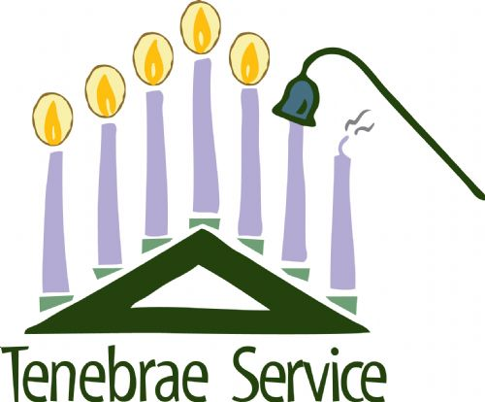

Good Friday, April 3, 2026

Service of Tenebrae
TENEBRAE means “darkness” or “shadows.” This solemn service dates back to the seventh or eighth century and is characterized by growing darkness.

We will experience the rhythm of a reading, a verse of a hymn, and the extinguishing of candles as the service progresses toward darkness. No other service during the entire church year is taken more directly from the Scriptures. It provides us with a powerful impression of the awful consequences of our sin and of the magnitude of our Savior’s sacrifice.

Dialogue

P: And this is the judgment, that the light has come into the world,
and we loved darkness rather than light.
C: God is light, in whom there is no darkness at all.

P: for God sent the Son into the world, not to condemn the world,
but that the world might be saved through him.
C: Everyone who does evil hates the light, and does not come
to the light. But all who do what is true come to the light.

P: Come, let us worship in spirit and truth.

