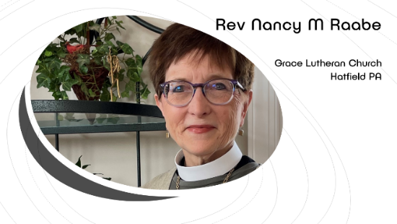
Catching the Spirit’s Fire
Day of Pentecost + May 19, 2024
Acts 2:2-21
Pastor Nancy M. Raabe
I have a friend named Becky, who I got to know at seminary. We have remained close, as our lives have followed similar paths in different parts of the country. Yesterday in one of our long talks Becky gave me this memorable phrase:
“Miracles happen every day. We just have to be aware.”
This might not resonate with what most people think of as miracles – astonishing, highly unusual occurrences such as those performed by Jesus -- exorcisms, healings. Legions of demons coming out of the Gerasene demoniac and plunging into the lake to their deaths. The hemorrhaging woman whose 18 years of bleeding was suddenly stopped by touching the hem of Jesus’ cloak. And one of our favorites, water turned to wine…the best part of that story being that the servants were the first to notice.
When you look up the word “miracle,” though, you find a definition for something like this: “A surprising and welcome event that is not explicable by natural or scientific laws and is therefore considered to be the work of a divine agency.”
Members and friends of Grace, here in person and watching online: Doesn’t that include SO MUCH of what happens to us, every day, just like my friend Becky says? Because all of life is the work of a divine agency—specifically, the Holy Spirit. For these ten minutes right now I want you to expand your mind and stretch your horizons to be able to see the Holy Spirit constantly at work – stirring up, directing, empowering, sparking, sparkling, flaming. Kids, wave those sparklers!
Can you feel the Spirit here? I can! Oh, right, well that’s YOU, you may be thinking. “She has too many crazy ideas.” “All she wants to do is spend money.” Yes, but what is my purpose here if not help stir up the Spirit’s power – something that all of you can be doing as well?
And not only “can” but “should,” because we are at a critically important juncture in the life of this congregation. I think we can all finally agree that the good old days are not coming back. And we may be starting to see that some of our old ways of doing things are losing steam. The same old, same old may no longer be viable.
Instead, we need to realize that miracles driven by the Holy Spirit are happening every day.
Miracles are happening such as, when you lead the worst confirmation class that you can imagine because you haven’t structured the time well and the students are spiraling out of control, and as you leave, thanking that God no one was hurt and no property was damaged, you wonder whether you should even continue to be a pastor -- and as the next class approaches you pray for the Holy Spirit to come down, and ten everyone catches fire and it’s the best class ever, and you don’t have to think about retiring from church work in shame after all.
Miracles are happening every day, such as when you think, “If only we had a basketball hoop so the kids don’t keep throwing the ball against the walls or up into the light fixtures, and then all of a sudden you do. (Slugg family, you work a lot of miracles in our midst.)
Miracles are happening every day, such as when the hazy two-dimensional outline of the youth group you have been praying for suddenly leaps into three dimensions and becomes a reality.
Miracles are happening every day, such as when the WELCA group is on the verge of disbanding for lack of initiative, and then the Books for Babies drive brings in tubs books and then suddenly they’ve planning a “high tea” in October that is sure to be a big hit.
And miracles are on the verge of happening, such when you say “If only we had a fall festival in the parking lot,” and then the next you hear are, “Let’s celebrate 120 years of Grace with a fall festival in the parking lot.” (Now don’t get worried, everyone – those words are as far as it’s gotten.)
But God has even more in mind for us than miracles every day. The Holy Spirit is pushing and pulling us to be church in an entirely new way. I don’t mean that suddenly we’re going to embrace rock music and be worshiping outside, but that we are being called to think about who we are and what we are doing from a fresh perspective. Who can we become for the blessing of the world? What do we have to offer to the community in a way that can inspire the Borough of Hatfield to catch fire?
I know you still recoil at that phrase, but I want to go back to that devastating event 12 ½ years ago because it inspired one of the wisest comments I’ve heard in my time here. One day the subject of the fire came up in conversation with Mabel Hoepfl, who died last year at age 92. Mabel looked me in the eye and said in her forthright way, “That fire was a blessing.”
What she meant was that it enabled us to have this beautiful worship space and our airy, highly functional fellowship hall. Without the fire, we would likely still be worshiping against a cement block background. Instead we have this miracle, given to us by fire.
I want to share with you a poem by Jan Richardson about exactly this. It is called “What Fire Gives,” based loosely on our Acts 2 reading. It is from Circle of Grace: A Book of Blessings for the Seasons. [Read]
We now have all this. How can we bring into God’s fullness what fire began?
A few days ago I performed yet another graveside service of the kind that are becoming more common. It was a particularly sad death, and the small group that gathered was hanging on every word. When I came to the line that seems to hold the breadth of time and creation in just a few words – “earth to earth, ashes to ashes, dust to dust” – I heard someone begin to sob quietly. Yes, loss is difficult, yet our funeral liturgy is about resurrection and hope, not finality and death.
The message of Pentecost is that ashes do not have the final word. Instead, the fire of the Spirit sweeps over us to bless, to call, to inspire, and to empower understanding. Remember that what amazed and astonished the crowd on that first Pentecost was not the babble of different dialects but the fact that each of them understood what was being proclaimed about God’s deeds of power, each in their own language. Everyone heard, and understood.
How can we open ourselves to the God’s grace through the Spirit’s power? How can we develop our ability as the body of Christ to listen attentively to the voices around us? What are the needs in our community, and how can we respond with the power of grace that the Spirit brings? How can we become agents for others of the truth that miracles really do happen every day? Amen.

